I HAVE A  FEVER | I AM  VOMITING | I HAVE  DIARRHEA | I HAVE A  RASH | I HAVE AN  EYE INFECTION | I HAVE BEEN TO THE  HOSPITAL OR DR.
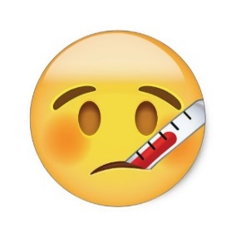
TEMPERATURE OF 100.0  OR HIGHER OR  Positive for FLU*COVID** | WITHIN THE PAST 24 HOURS | WITHIN THE PAST 24 HOURS | BODY RASH WITH ITCHING OR FEVER | REDNESS, ITCHING, AND/OR “CRUSTY” DRAINAGE FROM EYE | HOSPITAL STAY AND OR ER/DR VISIT and am not cleared to return
I AM READY TO GO BACK TO SCHOOL WHEN I AM…
FEVER FREE FOR 24 HOURS WITHOUT THE USE OF FEVER REDUCING MEDICATIONS  I.E. MOTRIN OR TYLENOL. If you are Positive for the flu see* | FREE FROM VOMIT FOR 24 HOURS AND BE ABLE TO HOLD DOWN AT LEAST 2 SOLID MEALS | FREE FROM DIARRHEA FOR 24 HOURS. STOOLS HAVE RETURNED TO NORMAL AND FEVER IS GONE | FREE FROM RASH, ITCHING OR FEVER. I HAVE BEEN EVALUATED BY MY DOCTOR IF NEEDED | EVALUATED BY MY DOCTOR AND HAVE A NOTE TO RETURN TO SCHOOL. 24 HOURS OF DROPS HAVE BEEN GIVEN IF PERSCRIBED | RELEASED BY MY MEDICAL PROVIDER TO RETURN TO SCHOOL AND A PHYSICIAN’S NOTE ACCOMPANIES THE CHILD TO SCHOOL
*Kansas Department of Health & Environment (KDHE) rules say a child positive for the flu cannot return to school until 5 days after the onset of the first symptom or 24 hours fever free without the aid of fever reducing medications, whichever is longer.
** COVID Day 0 is the first day of symptoms or the day of testing if asymptomatic. The student must remain out of school for 5 days. They need to be fever free for 24 hours without the use of medication and symptoms have improved

